17th July 2017

**World Touring Car Championship Battle Heats up**

Yann Ehrlacher was ecstatic as he managed his maiden FIA World Touring Car Championship victory at the WTCC Race of Argentina, converting a stupendous career-first standing start pole position into victory number one for him and the privateer RC Motorsport team.

The 21-year-old -nephew of four-time WTCC champion Yvan Muller stormed away from the start only for contact with Tom Chilton to drop him back to second place. However, officials deemed that Chilton had gained an unfair advantage and penalised him with a five-second time penalty, which dropped him from first to fourth at the finish of the Opening Race.

In the main race, Hungarian star, Norbert Michelisz was smiling again after his second consecutive win and as factory Honda team-mate Tiago Monteiro gained the edge in the title chase with the runner-up spot. Heading into the summer break, Monteiro leads Thed Björk by 12 points with Michelisz up to third.

Björk’s Main Race podium gave the works Polestar Cyan Racing team some reason for cheer after Catsburg’s unfortunate day and a retirement for Néstor Girolami in the Opening Race following the onset of an electrical issue. With Honda out-scoring its rival make, it’s the Japanese firm that now leads the World Touring Car Championship for Manufacturers heading to the next event in China in the autumn.

The home boy Esteban Guerrieri used crowd support to deliver one of his best weekends in the WTCC so far with a third and a fourth in the two races at Circuito Termas de Río Hondo.

John Filippi extended his point-scoring run with eighth in the Opening Race, while Ryo Michigami charged through from P16 to P10 for his first points since the season-opening WTCC Race of Morocco.

Meanwhile the chase for WTCC Trophy title intensified with the results of the weekend racing in Argentina. After 12 rounds, the top three drivers – Mehdi Bennani, Tom Chilton and Rob Huff – are equal on 87 points showing the extremely competitive nature of this season’s WTCC.

Huff was ahead before the trip to South America but has now lost ground to Bennani and Chilton as they moved up equal on points. The WTCC Trophy is the championship within a championship for independent racers. Bennani is the reigning champion after losing out on the crown to factory Honda driver Norbert Michelisz the previous season.

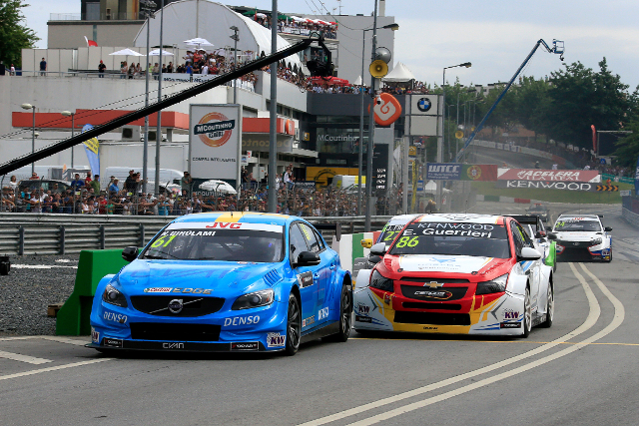

*WTCC-Argentina-17*

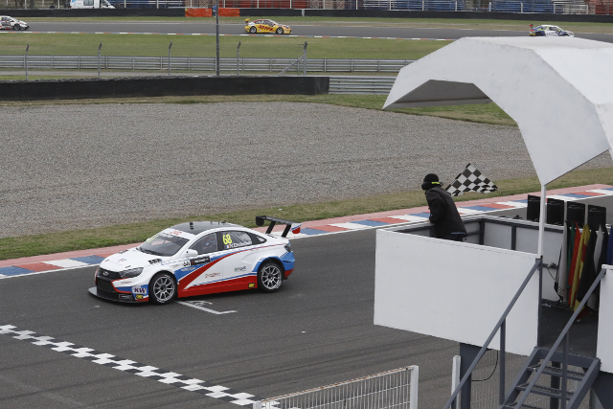

*WTCC-Maiden-Victory-Ehrlacher-17*

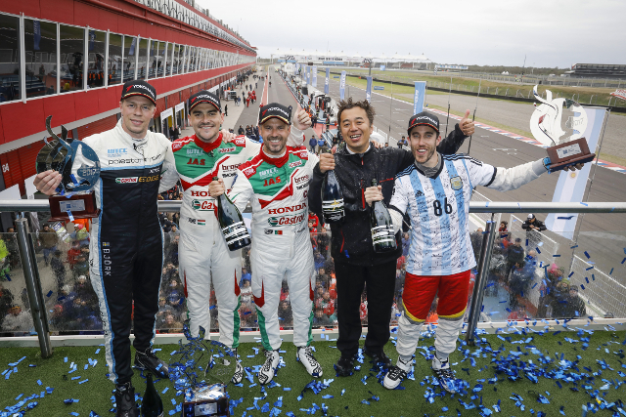

*WTCC-Smiles-all-round-Argentina-17*